|  |  |  |  |  |
| --- | --- | --- | --- | --- |
| Shree Sainath Packaging | | | | |
|  |  | | |  |
| Complete Packaging solution | | | | |
|  | | Since 2007. |  | |

|  |  |  |
| --- | --- | --- |
| Group of people | |  | | --- | | TABLE OF CONTENTS |   Introduction 4  1. Executive Summary 5  2. Company Overview 6  3. Business Description 7  4. Market Analysis 9 |

|  |
| --- |
| Introduction |

Established in 2007, **Shree Sainath Packaging** is a trusted name in the packaging industry, based in Indore, Madhya Pradesh. We specialize in manufacturing and supplying a wide range of packaging solutions, including **BOPP bags, woven sack bags, and non-woven bags**. With a focus on quality, durability, and customer satisfaction, we cater to the diverse needs of clients across industrial and commercial sectors.

What began as a small manufacturing unit has grown steadily through commitment, consistency, and a deep understanding of the packaging industry. Our products are crafted with care and precision, ensuring they meet the functional and branding needs of our customers.

At Shree Sainath Packaging, we believe that packaging is not just about wrapping a product—it's about protecting it, enhancing its appeal, and supporting the success of the businesses we serve. With over 15 years of experience, we continue to evolve with the market, while staying rooted in our core values: **quality, trust, and service**.

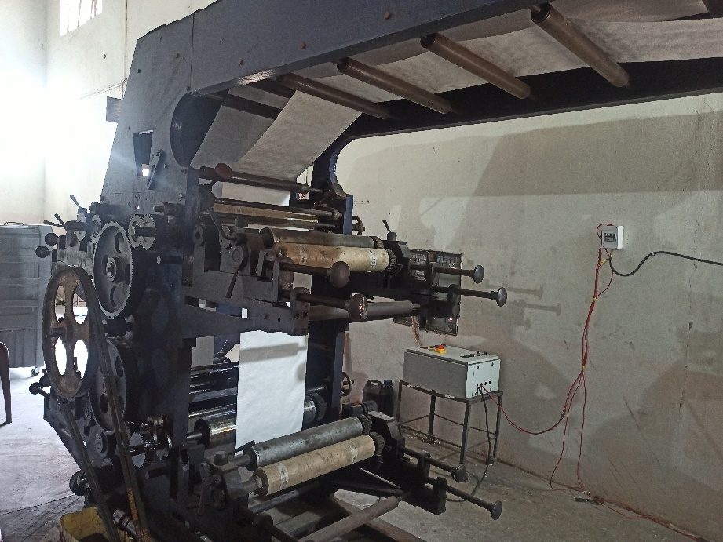

It is recommended to complete the Executive Summary last, after all of the other sections have been completed. As information is filled in, from the Company Overview to the Financial Plan, the writing should tell the story of the motivation and vision behind the business. Be sure to include what will make the business successful, how success will be achieved, and how success will be measured.

It is important to keep the business plan updated in order to see progress, celebrate success, and adjust where issues arise. This is best done on a quarterly, if not monthly, basis.

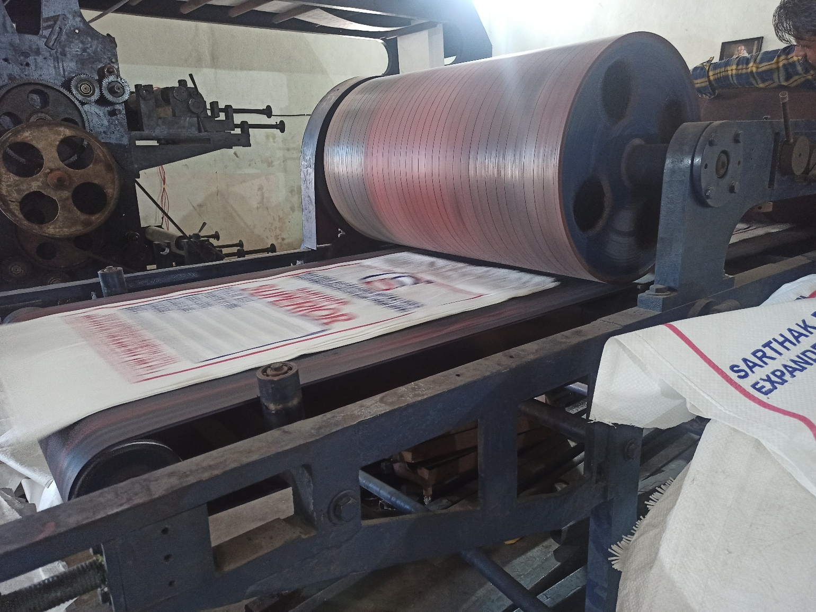

|  |
| --- |
| Executive Summary |

**Shree Sainath Packaging, established in 2007 and based in Indore, Madhya Pradesh, is a dedicated manufacturer of high-quality packaging products including BOPP bags, woven sack bags, and non-woven bags. Over the years, the company has built a strong reputation for delivering durable, reliable, and customized packaging solutions to a wide range of industries including agriculture, FMCG, textiles, and retail.**

**With over 15 years of hands-on experience, Shree Sainath Packaging operates with a commitment to quality, affordability, and timely delivery. The company’s focus is on understanding client requirements and offering packaging that not only protects the product but also enhances its presentation and value in the market.**

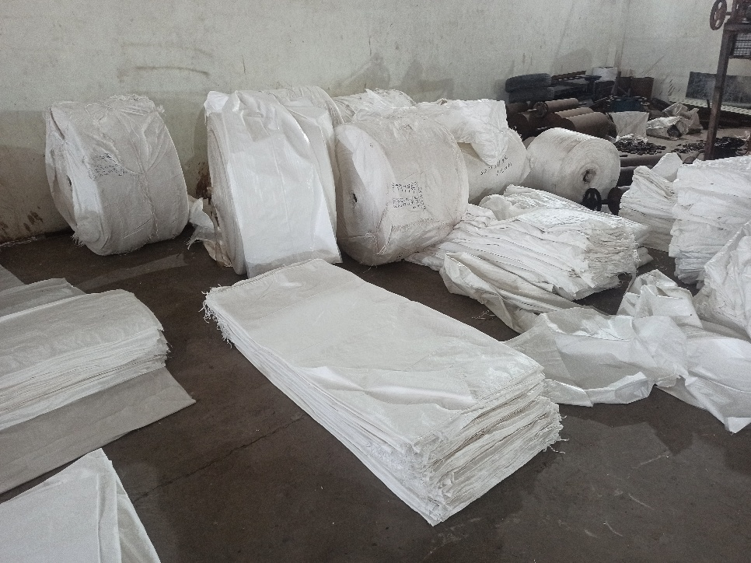**Led by a small but skilled team, the company prioritizes customer satisfaction, ethical business practices, and continuous improvement in both manufacturing and service. Shree Sainath Packaging is well-positioned to scale operations and diversify its offerings to meet the growing demand for eco-friendly and customized packaging solutions.**

**Moving forward, the company aims to expand its market presence, invest in efficient manufacturing technology, and explore B2B and digital channels to reach new customers across India.**

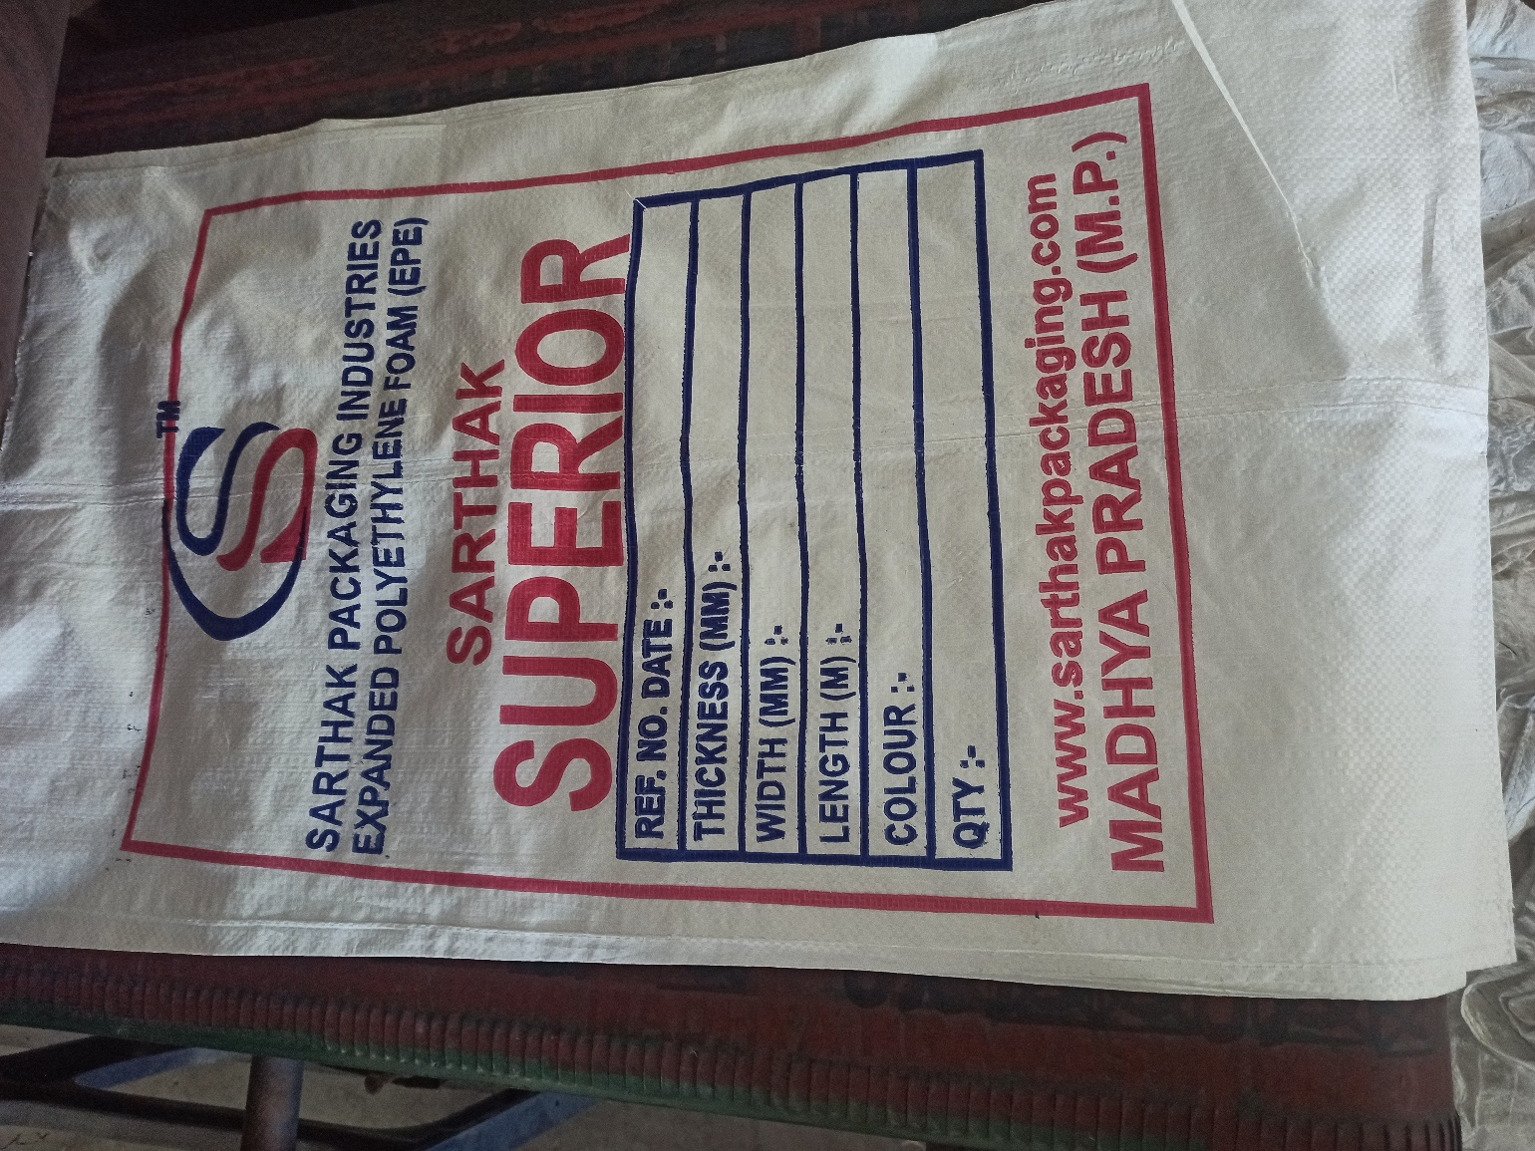

|  |
| --- |
| Company Overview |

**Business Name:** Shree Sainath Packaging  
**Founded:** 2007  
**Location:** Indore, Madhya Pradesh, India  
**Business Type:** Manufacturer  
**Industry:** Packaging and Industrial Supplies  
**Key Products:** BOPP Bags, Woven Sack Bags, Non-Woven Bags  
**Ownership:** Self Owned  
**Contact Person:** UmeshSharma  
**Team Size:** Up to 10 employees  
**Service Area:** Pan-India

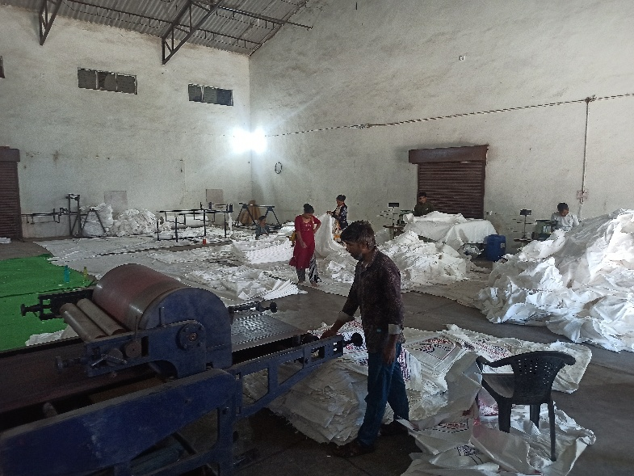**Shree Sainath Packaging** is a well-established packaging manufacturing company committed to delivering durable, cost-effective, and high-quality packaging solutions. Headquartered in Indore, Madhya Pradesh, we have been serving clients across India since 2007 with products that meet both industrial and commercial needs.

Our core strength lies in our ability to manufacture a variety of packaging products that are not only functional but also customizable based on the unique requirements of each client.

Operating with a lean yet skilled team, our company emphasizes long-term relationships, quality assurance, and customer satisfaction. As we continue to grow, we are exploring new technologies, materials, and market segments—especially in eco-friendly and reusable packaging—to stay ahead of industry trends and deliver greater value.

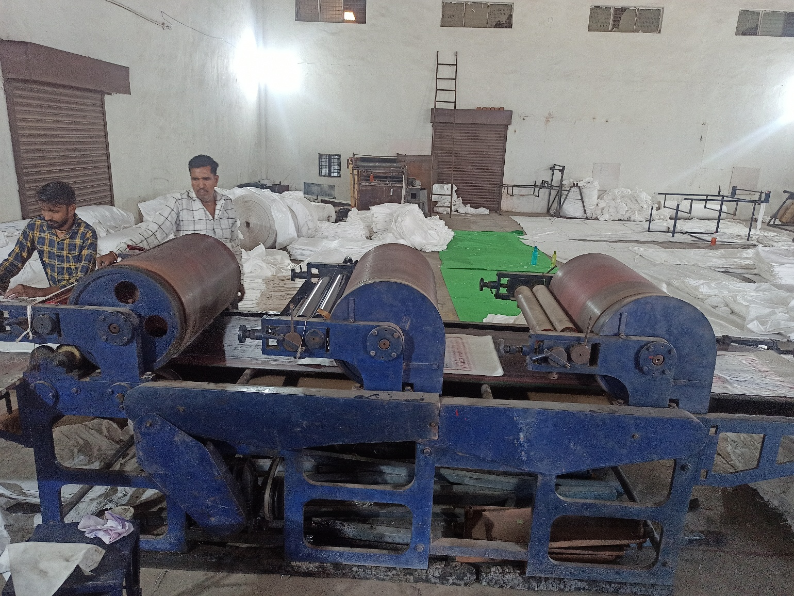

|  |
| --- |
| Business Description |

This section will first frame the business opportunity and should answer the question: what problem(s) is the company trying to solve? Use a case example to describe the customers’ pain point and how it is solved today. If the business’ service addresses something the market has yet to identify as a problem (for instance, a new mobile app or a new clothing line), then also describe how the business’ solution reduces stress, saves money, or brings joy to the customer.

After framing the opportunity, describe the service in detail and how it is the solution the business offers, how it solves that problem, and what benefits customers will receive.

This section also describes in more detail how the services will be rendered and the pricing structure (e.g., fixed rate versus an hourly fee). Describe how the company plans to differentiate from its competitors. What is the target market and how can the customer capitalize on your unique offering?

Depending on the type of business, the following sections may or may not be necessary. Only include relevant sections and remove everything else.

|  |
| --- |
| Market Analysis |

The packaging industry in India has witnessed significant growth over the past decade, driven by rising demand from sectors such as agriculture, FMCG, retail, pharmaceuticals, and e-commerce. As businesses shift focus toward efficient, durable, and eco-friendly packaging, the market for **BOPP bags, woven sacks, and non-woven bags** has expanded rapidly.

**Industry Demand**

* **Agricultural packaging** for grains, seeds, fertilizers, and animal feed continues to be a key driver of woven and BOPP bags demand.
* **Retail and FMCG brands** are increasingly using printed BOPP and non-woven bags for branding and consumer packaging.
* The government’s push for **sustainable and reusable alternatives** has also encouraged businesses to adopt **non-woven bags** in place of single-use plastic.

**Market Size & Growth**

* The Indian flexible packaging market is projected to grow at over **10% CAGR** in the next five years.
* BOPP and woven sack segments are steadily growing due to their reusability, moisture resistance, and strength.
* Non-woven bags are gaining popularity in urban markets due to their eco-friendly appeal and reusability.

**Customer Needs**

Modern customers demand:

* **Customization** in terms of size, print, and material
* **Durability** to withstand transport and storage
* **Aesthetic packaging** that supports brand visibility
* **Sustainability**, reducing environmental impact

**Opportunities for Growth**

For companies like **Shree Sainath Packaging**, the current market offers numerous opportunities:

* Expansion into **eco-friendly product lines**
* Catering to **e-commerce and direct-to-consumer brands**
* Building **long-term B2B relationships** with wholesalers and agro-industrial companies
* Leveraging digital platforms for lead generation and brand visibility

